EXPERIMENT 1

Clustering based data analytics using R/Python. (K-Means, SOM algorithms)

AIM
To implement and compare clustering algorithms – K-Means and Self-Organizing Map (SOM) – for data analytics using Python, and evaluate their performance on the Tips dataset.

PROCEDURE
- Import required libraries: numpy, pandas, matplotlib, sklearn (KMeans, StandardScaler, silhouette_score, adjusted_rand_score), and minisom.
- Load the Tips dataset using seaborn's load_dataset() function.
- Select the features: total_bill, tip, and size for clustering.
- Normalize the features using StandardScaler.
- Apply K-Means clustering with n_clusters=3 and random_state=42.
- Store cluster labels and centroids.
- Visualize K-Means clusters using a scatter plot.
- Install and import MiniSom library.
- Initialize MiniSom with a 10x10 grid, input_len=3, sigma=1.0, learning_rate=0.5.
- Train the SOM with 1000 iterations.
- Assign each data point to its Best Matching Unit (BMU).
- Visualize SOM clustering using a scatter plot.
- Compute Silhouette Scores for both algorithms.
- Compute Adjusted Rand Index (ARI) for both algorithms using quantile-based ground truth.
- Compare and declare the winner based on scores.

CODE

import numpy as np
import pandas as pd
import matplotlib.pyplot as plt
import seaborn as sns
data = sns.load_dataset('tips')
data.head()
X = data[['total_bill', 'tip', 'size']].values
from sklearn.preprocessing import StandardScaler
scaler = StandardScaler()
X_scaled = scaler.fit_transform(X)
from sklearn.cluster import KMeans
kmeans = KMeans(n_clusters=3, random_state=42)
kmeans.fit(X_scaled)
labels = kmeans.labels_
centroids = kmeans.cluster_centers_
plt.figure(figsize=(6,5))
plt.scatter(X_scaled[:,0], X_scaled[:,1], c=labels, cmap='viridis')
plt.xlabel('Total Bill (Scaled)')
plt.ylabel('Tip (Scaled)')
plt.title('K-Means Clustering on Restaurant Dataset')
plt.show()

!pip install minisom
from minisom import MiniSom
som = MiniSom(x=10, y=10, input_len=3, sigma=1.0, learning_rate=0.5)
som.random_weights_init(X_scaled)
som.train_random(X_scaled, num_iteration=1000)
som_labels = [som.winner(x)[0]*10 + som.winner(x)[1] for x in X_scaled]
plt.figure(figsize=(6,5))
plt.scatter(X_scaled[:,0], X_scaled[:,1], c=som_labels)
plt.xlabel('Total Bill (Scaled)')
plt.ylabel('Tip (Scaled)')
plt.title('SOM Clustering (BMU-based) – Tips Dataset')
plt.show()
from sklearn.metrics import silhouette_score, adjusted_rand_score
silhouette_kmeans = silhouette_score(X_scaled, labels)
silhouette_som = silhouette_score(X_scaled, som_labels)
true_labels = pd.qcut(data['total_bill'], q=3, labels=[0, 1, 2]).astype(int).values
ari_kmeans = adjusted_rand_score(true_labels, labels)
ari_som = adjusted_rand_score(true_labels, som_labels)
print('Silhouette Score (K-Means):', silhouette_kmeans)
print('Silhouette Score (SOM):', silhouette_som)
print('ARI Score (K-Means):', ari_kmeans)
print('ARI Score (SOM):', ari_som)

OUTPUT
Silhouette Score (K-Means): 0.3549055441243031 Silhouette Score (SOM): 0.3128273737018978
Winner (Silhouette): K-Means (better-defined clusters)

ARI Score (K-Means): 0.3912645301058091 ARI Score (SOM): 0.0609522064892904
Winner (ARI): K-Means (closer to ground truth)
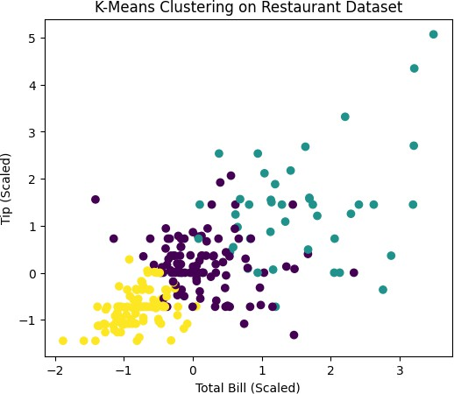
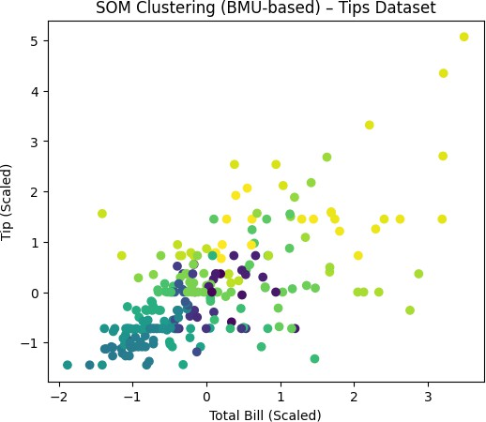

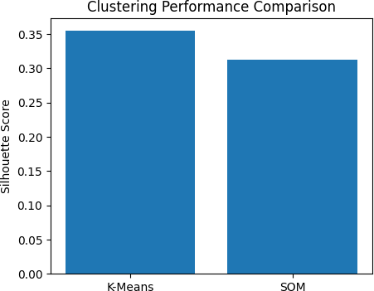

RESULT
K-Means clustering outperformed SOM on both Silhouette Score (0.354 vs 0.312) and Adjusted Rand Index (0.391 vs 0.061), indicating K- Means produced better-defined and more accurate clusters for the Tips dataset.

